ReactJS - HQL OUTPPUTS

- Create a React app.
Step – 1 : Check your node and react version. If not installed install them.
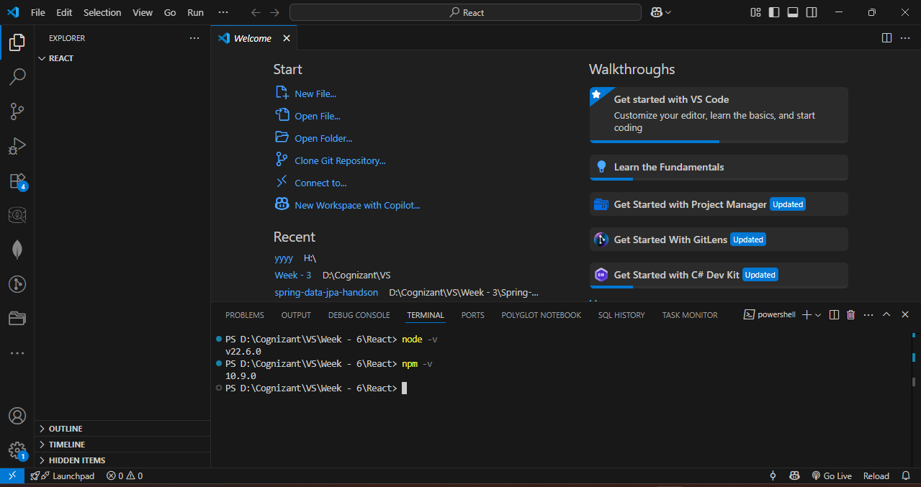

Step – 2 : Create a react app name it myfirstreact.
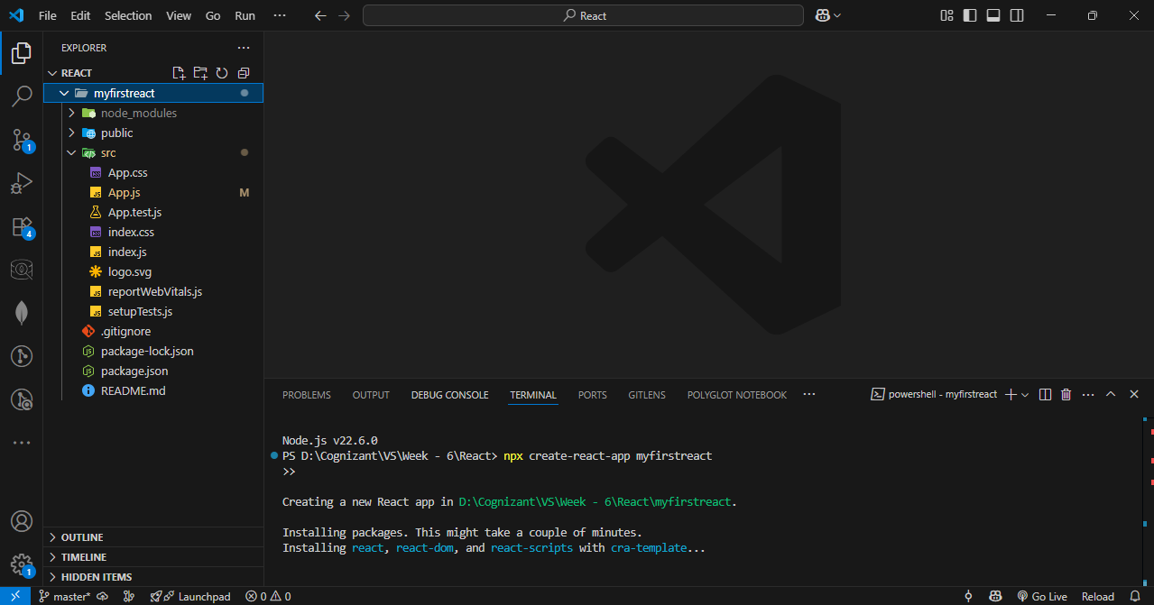

Step – 3 : Write code in app.js
Code :
import React from 'react';

function App() {
return (
<div>
<h1>Welcome to the first session of React</h1>
</div>
);
}

export default App;

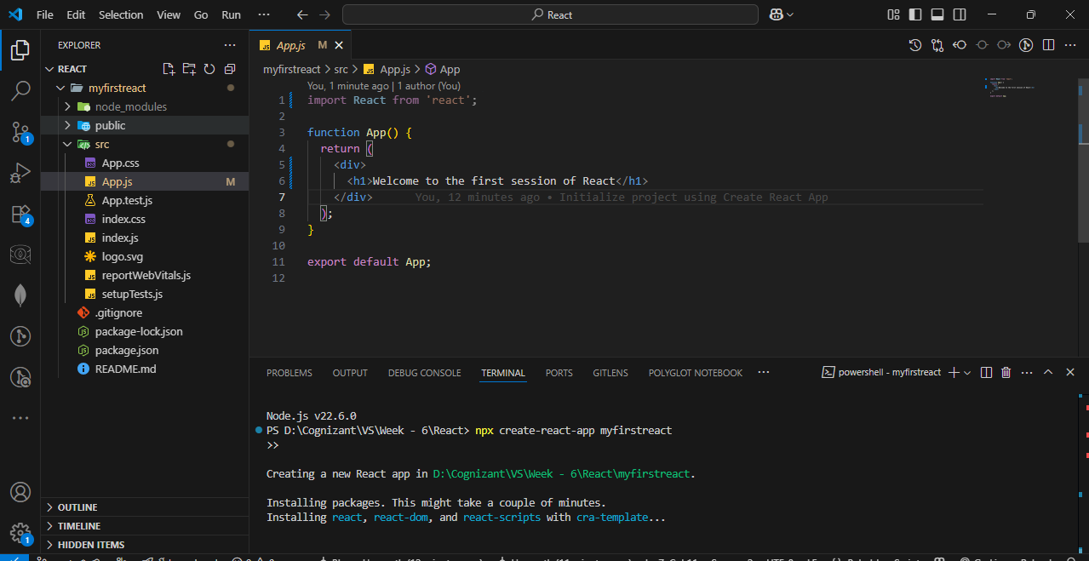

Step – 4 : Run the code.
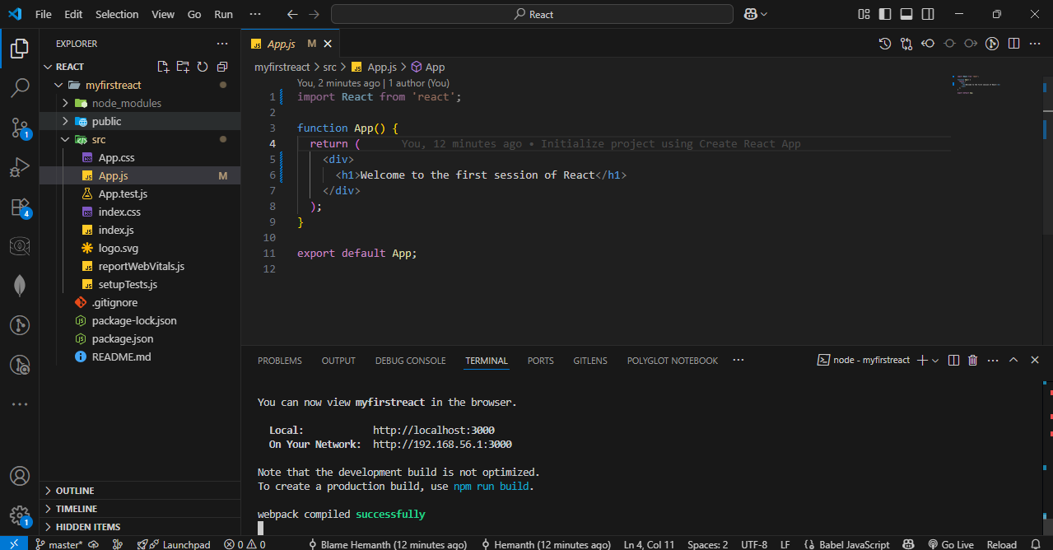

OUTPUT :
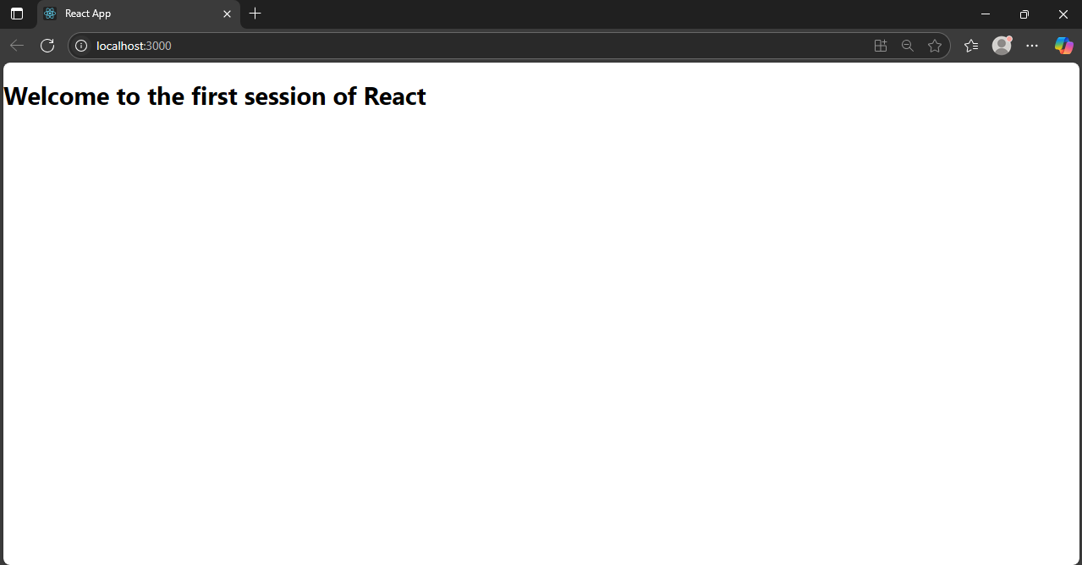

- Student Management Portal
Step – 1 : Create a react app named StudentApp.
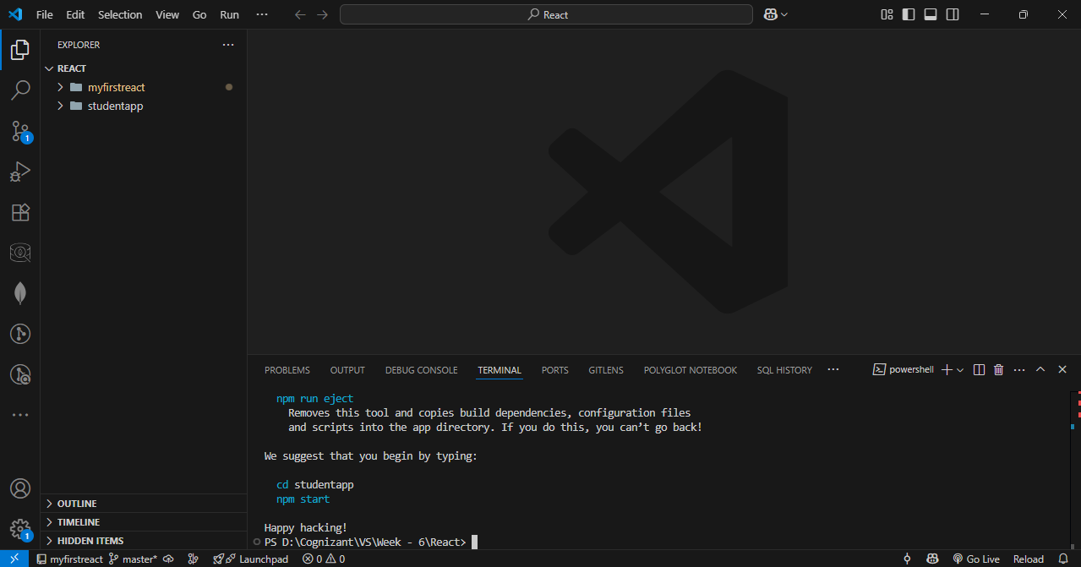

Step – 2 : Create three java classes Home.js, about.js and contact.js in src/components.
Home.js Code :
import React, { Component } from 'react';
class Home extends Component {
constructor(props) {
super(props);
}
render() {
return (
<div>
<h2>Welcome to the Home page of Student Management Portal</h2>
</div>
);
}
}export default Home;
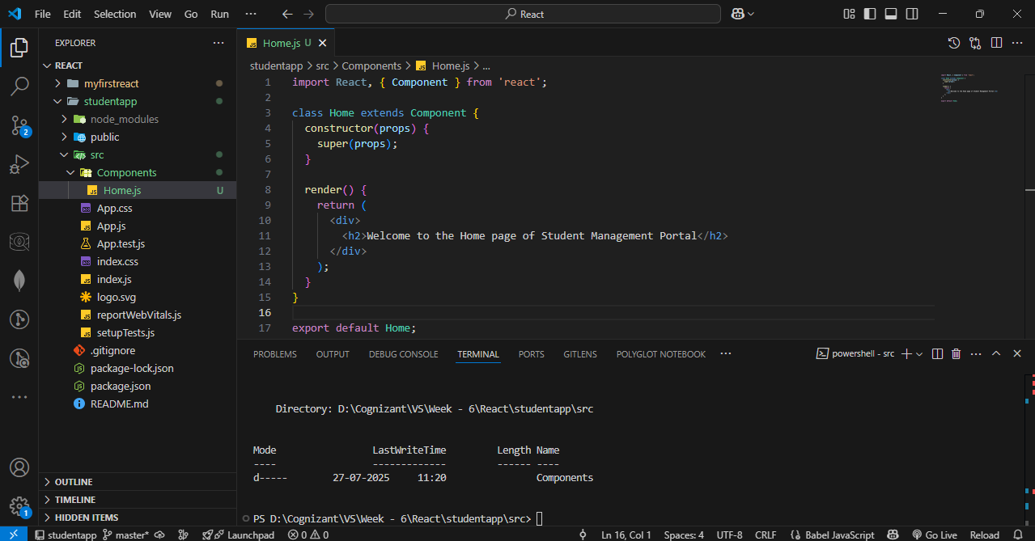
About.js Code :
import React, { Component } from 'react';
class About extends Component {
constructor(props) {
super(props);
}
render() {
return (
<div>
<h2>Welcome to the About page of the Student Management Portal</h2>
</div>
);
}
}
export default About;
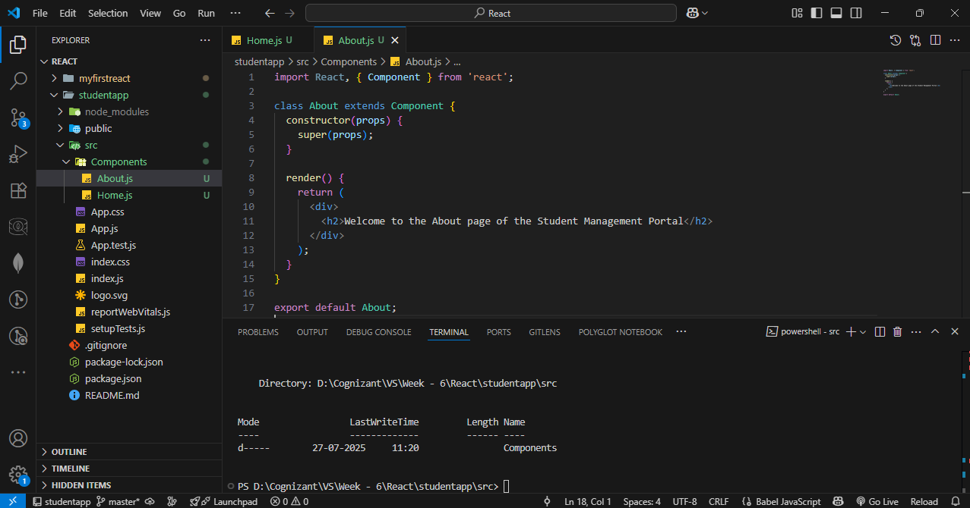

Contact.js Code :
import React, { Component } from 'react';
class Contact extends Component {
constructor(props) {
super(props);
}
render() {
return (
<div>
<h2>Welcome to the Contact page of the Student Management Portal</h2>
</div>
);
}
}
export default Contact;
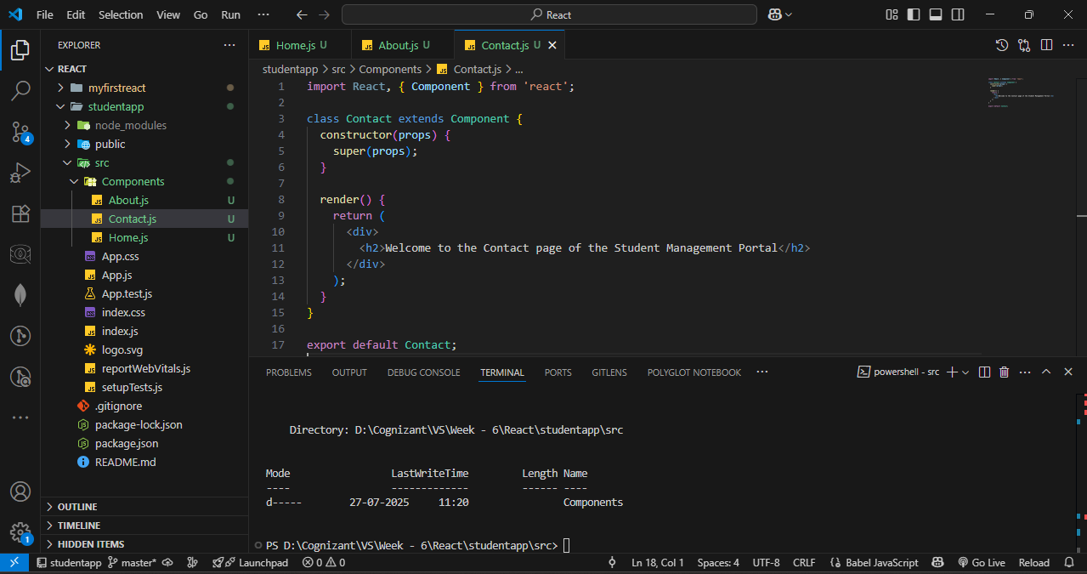

Step – 3 : Update App.js
Code :
import React from 'react';
import './App.css';
import Home from './Components/Home';
import About from './Components/About';
import Contact from './Components/Contact';
function App() {
return (
<div className="App">
<h1>Student Management Portal</h1>
<Home />
<About />
<Contact />
</div>
);}export default App;
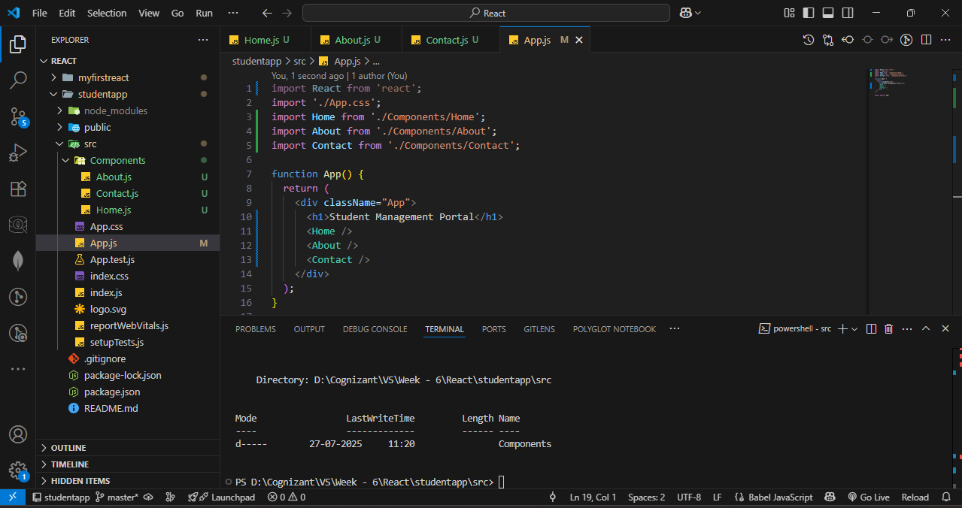

Step – 4 : Start the server.
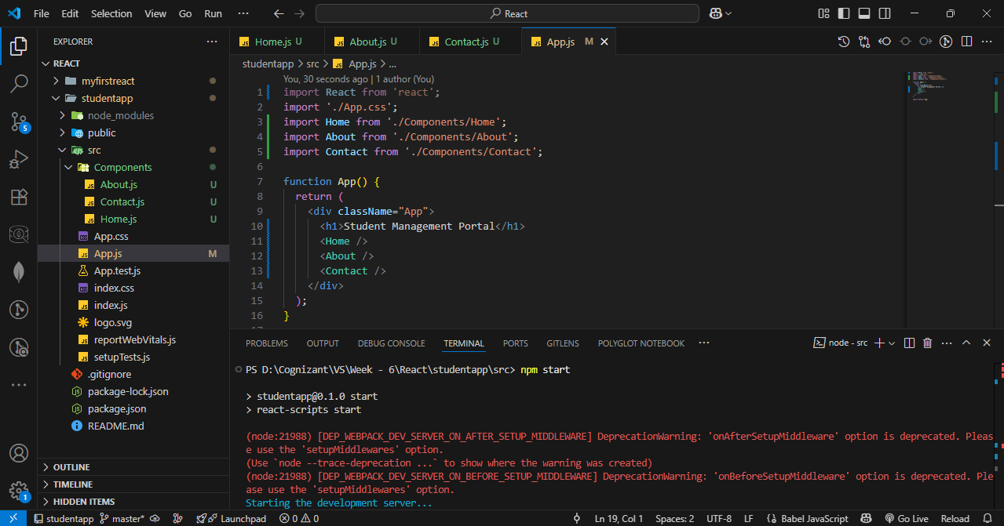

OUTPUT :
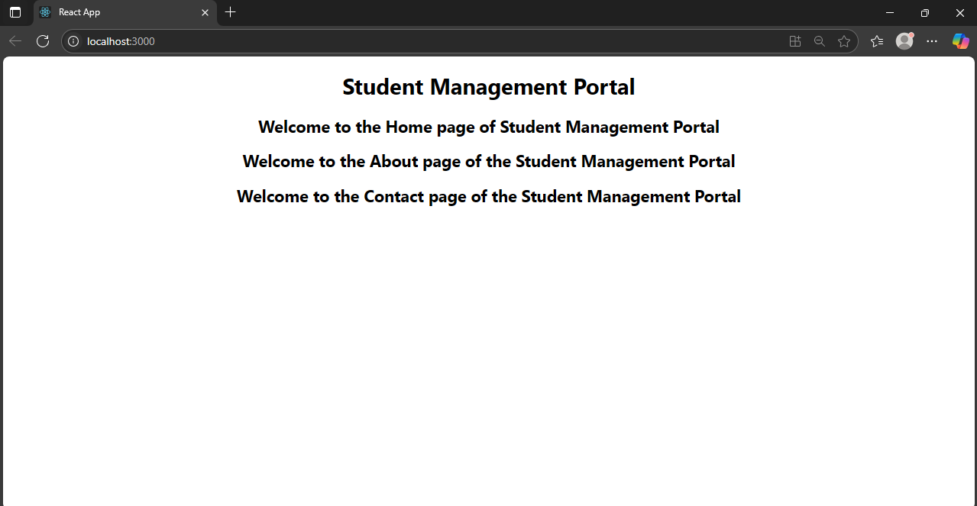

- Score Calucator App
Step – 1 : Create a react app named scorecaluculator app.
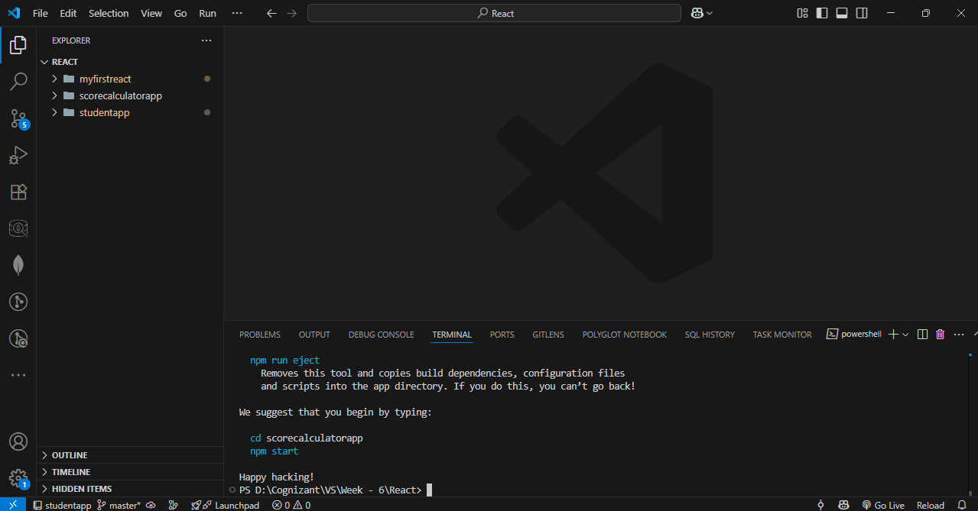

Step – 2 : Create a folder named components and create a CalculateScore.js file.
Code :
import '../Stylesheets/mystyle.css';
const percentToDecimal = (decimal) => {
return (decimal.toFixed(2) + '%');
};
const calcScore = (total, goal) => {
return percentToDecimal(total / goal);
};
export const CalculateScore = ({ Name, School, total, goal }) => (
<div className="formatstyle">
<h1><font color="Brown">Student Details:</font></h1>
<div className="Name">
<b><span> Name: </span></b>
<span>{Name}</span>
</div>
<div className="School">
<b><span> School: </span></b>
<span>{School}</span>
</div>
<div className="Total">
<b><span>Total:</span></b>
<span>{total}</span>
<span> Marks</span>
</div>

<div className="Score">
<b>Score:</b>
<span>
{calcScore(total, goal)}
</span>
</div>
</div>
);

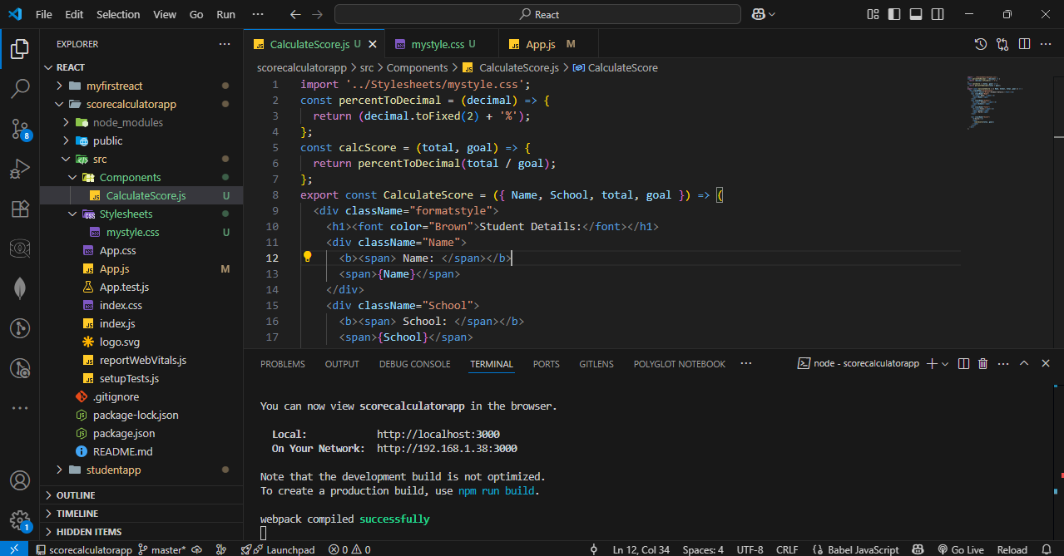

Step – 3 : Create a folder named Stylesheets and create mystyle.css.
Code :
.Name {
font-weight: 300;
color: blue;
}

.School {
color: crimson;
}

.Total {
color: darkmagenta;
}

.formatstyle {
text-align: center;
font-size: large;
}

.Score {
color: forestgreen;
}

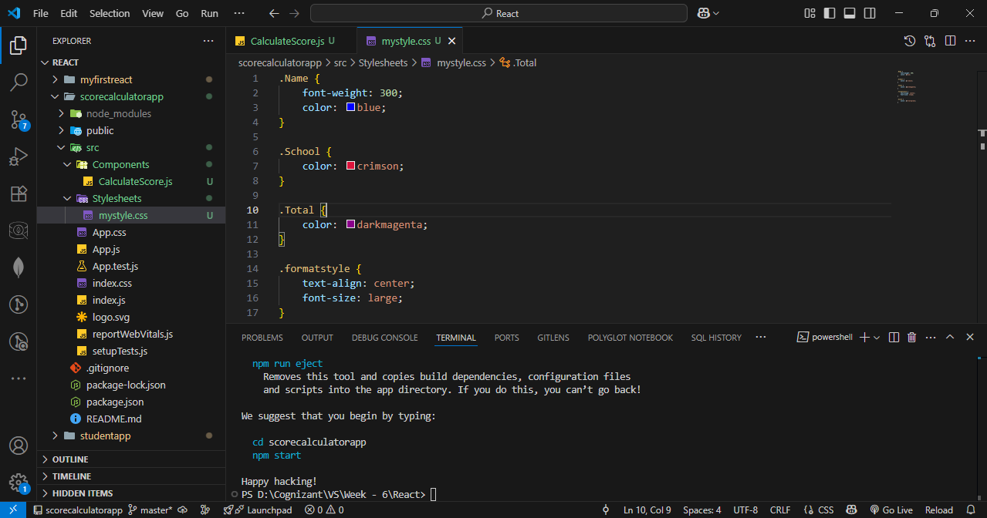

Step – 4 : Update app.js code.
Code :
import { CalculateScore } from './Components/CalculateScore';

function App() {
return (
<div>
<CalculateScore
Name={"Hemanth"}
School={"KL UNiversity"}
total={284}
goal={3}
/>
</div>
);
}

export default App;

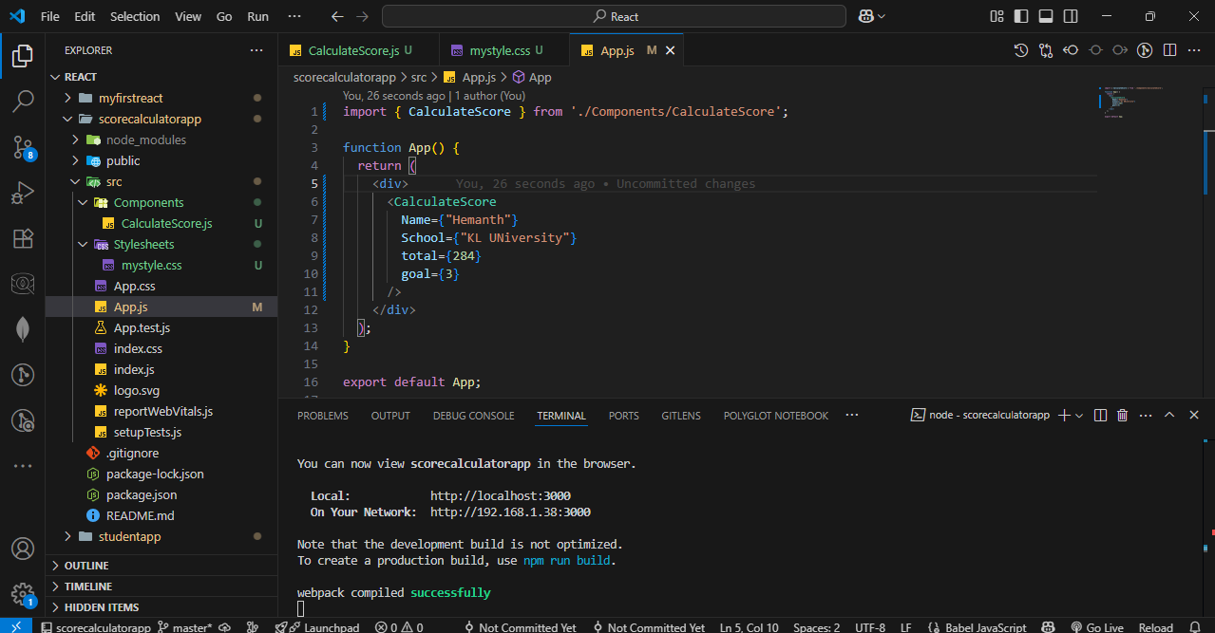

Step – 5 : Run the server.


OUTPUT :
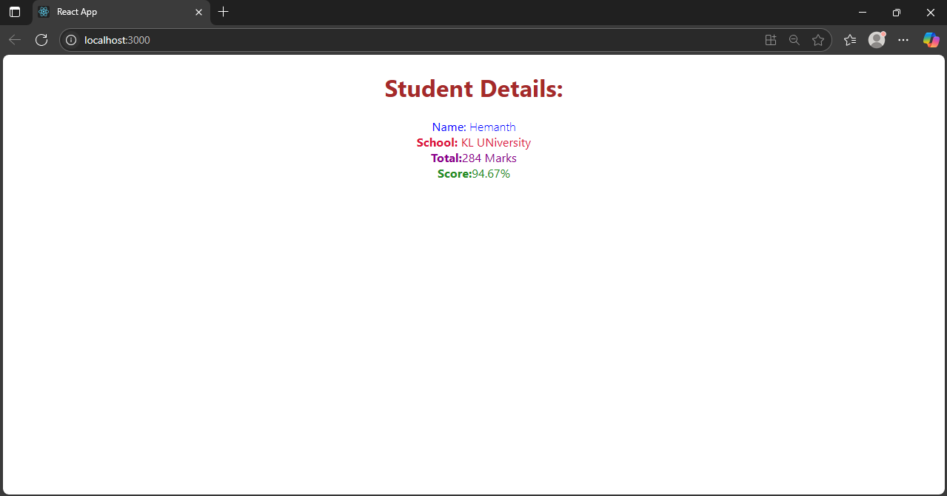

- Blog App
Step – 1 : Create a react app named blog app.
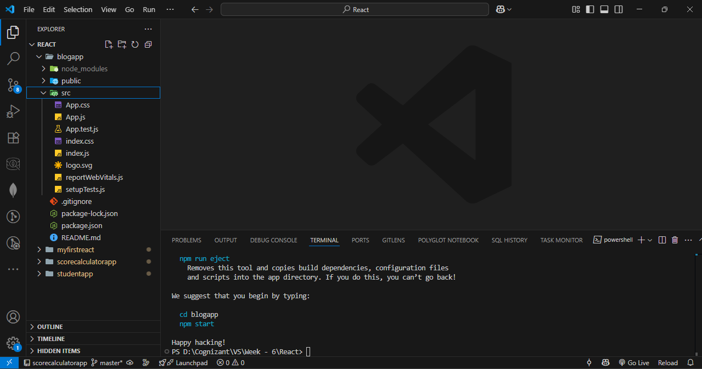

Step – 2 : Create posts.js and Post.js in src folder.
Posts.js Code :
import React from 'react';
import Post from './Post';

class Posts extends React.Component {
constructor(props) {
super(props);
this.state = {
posts: [],
hasError: false
};
}

loadPosts() {
fetch('https://jsonplaceholder.typicode.com/posts')
.then((response) => response.json())
.then((data) => this.setState({ posts: data }))
.catch((error) => {
console.error("Fetch Error:", error);
this.setState({ hasError: true });
});
}

componentDidMount() {
this.loadPosts();
}

componentDidCatch(error, info) {
alert("An error occurred while rendering posts.");
console.error("Error caught in componentDidCatch:", error, info);
this.setState({ hasError: true });
}

render() {
const { posts, hasError } = this.state;

if (hasError) {
return <h2>Something went wrong while loading posts.</h2>;
}
return (
<div style={{ padding: '20px' }}>
<h1>Blog Posts</h1>
{posts.slice(0, 10).map((post) => (
<Post key={post.id} title={post.title} body={post.body} />
))}
</div>
);
}
}
export default Posts;

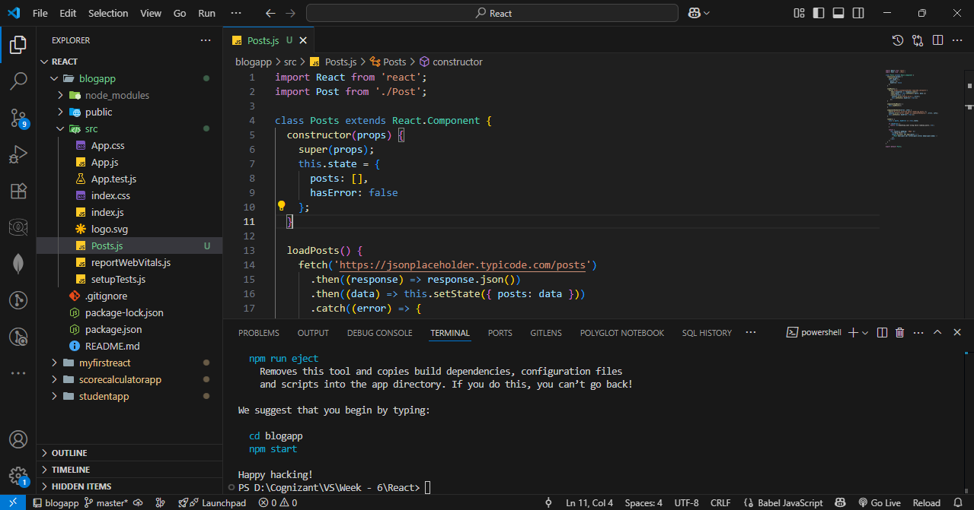

Post.js Code :
import React from 'react';

class Post extends React.Component {
render() {
const { title, body } = this.props;
return (
<div style={{ marginBottom: '20px', padding: '10px', border: '1px solid #ccc' }}>
<h3>{title}</h3>
<p>{body}</p>
</div>
);
}
}
export default Post;
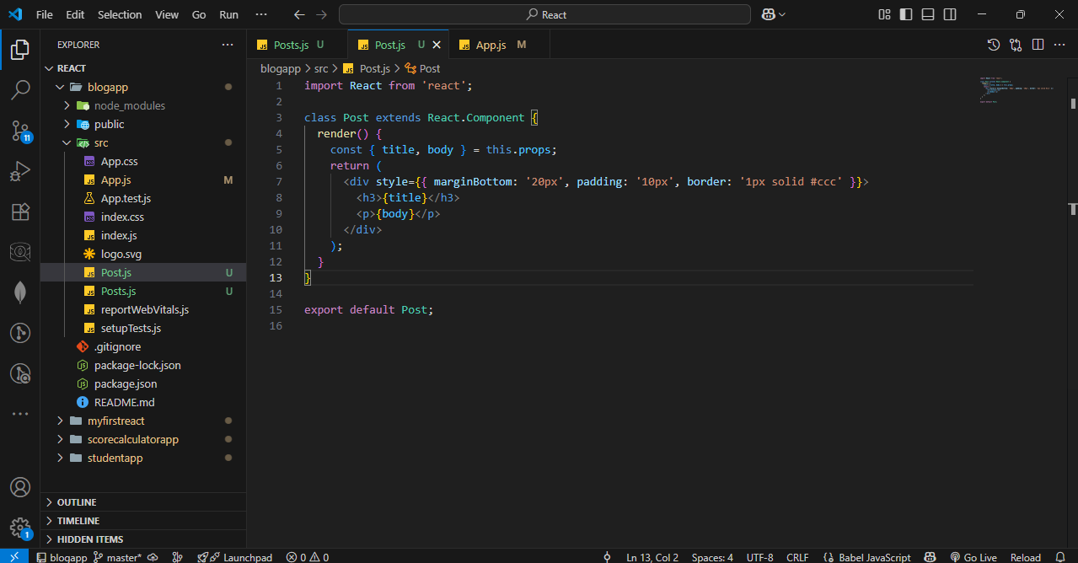
Step – 3 : Update app.js
Code :
import React from 'react';
import './App.css';
import Posts from './Posts';
function App() {
return (
<div className="App">
<Posts />
</div>
);
}
export default App;
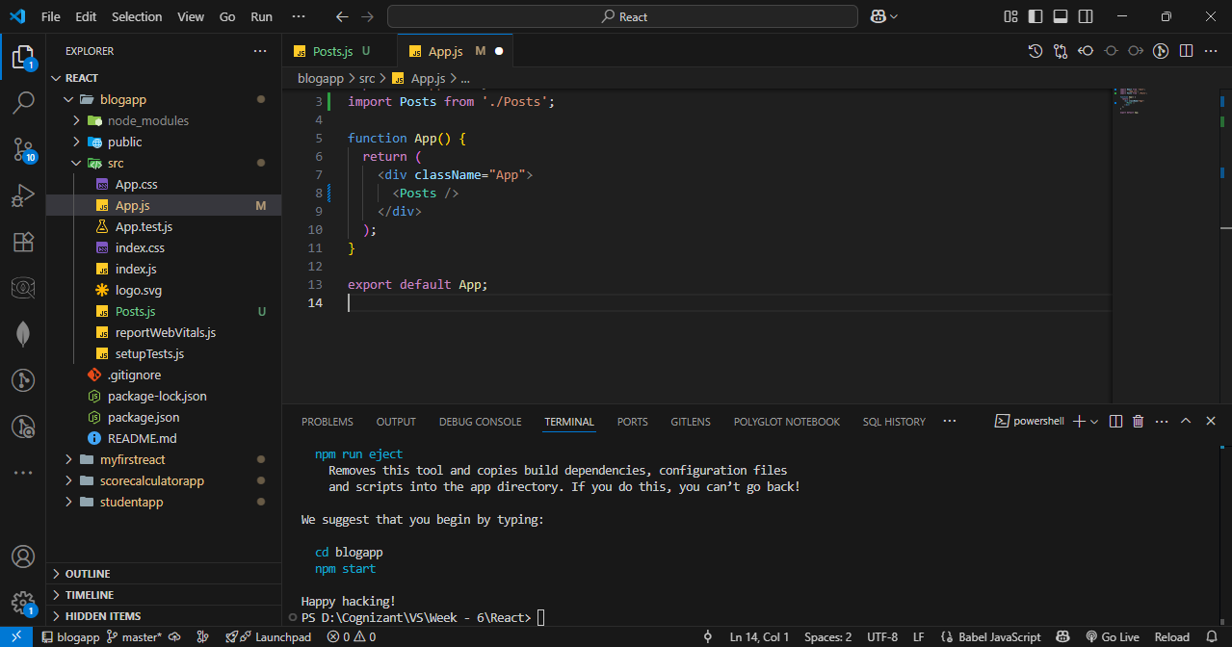

Step – 3 : Run the server.
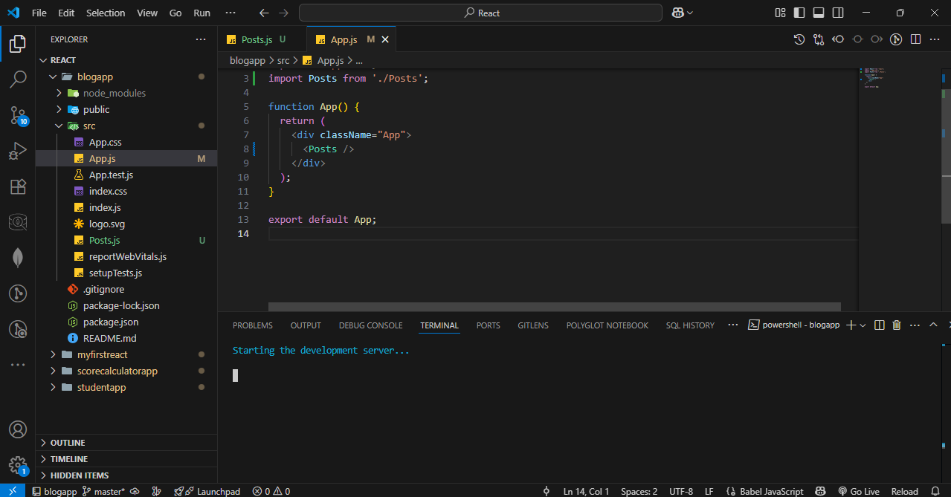

OUTPUT :
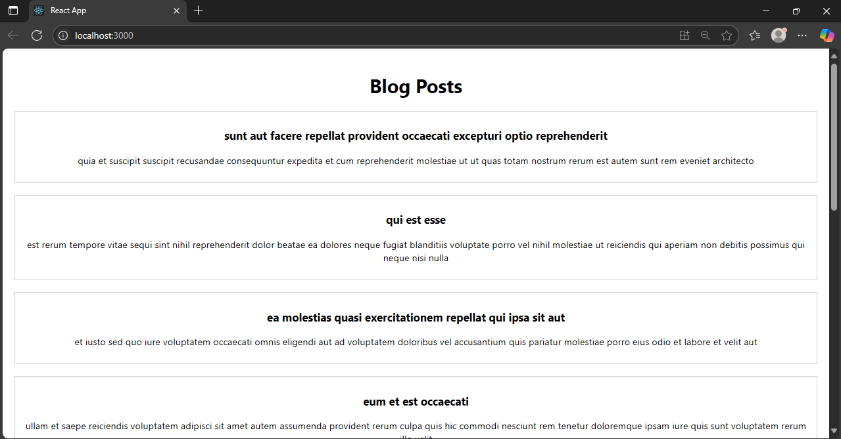

- Cohort tracker
Step – 1 : unzip cohorttracker.zip and install all dependencies.
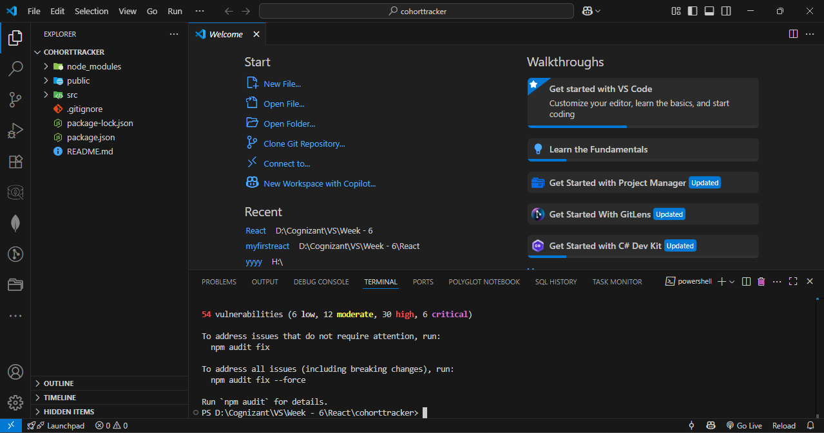

- Step – 2 : Create a new CSS Module in a file called CohortDetails.module.css.
Code :
.box {
width: 300px;
display: inline-block;
margin: 10px;
padding: 10px 20px;
border: 1px solid black;
border-radius: 10px;
vertical-align: top;
}
dt {
font-weight: 500;}
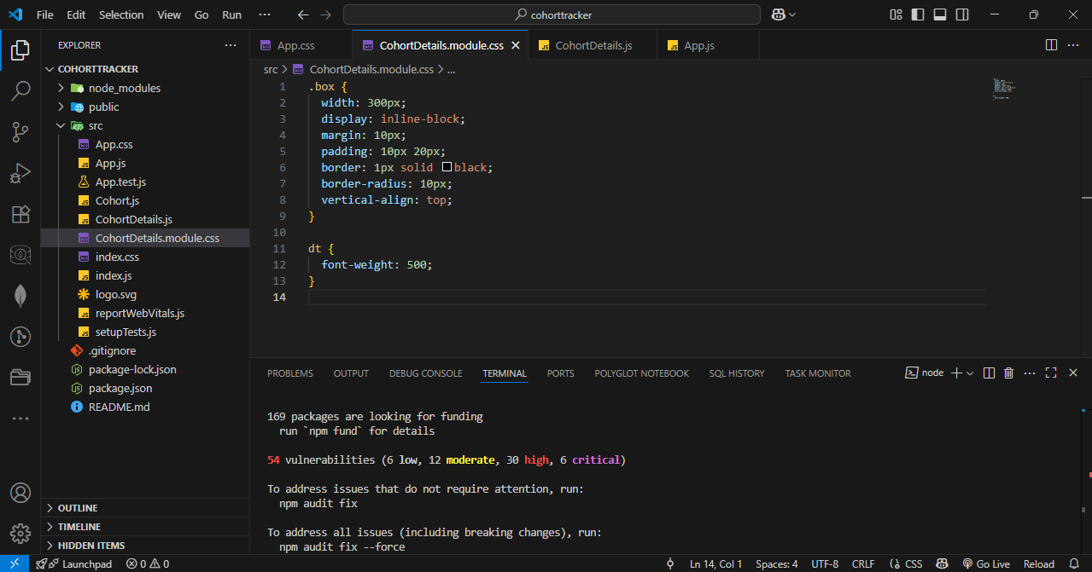

Step – 4 : Update CohortDetails.js
Code :
import React from 'react';
import styles from './CohortDetails.module.css';

function CohortDetails(props) {
const statusStyle = {
color: props.status.toLowerCase() === 'ongoing' ? 'green' : 'blue',
fontWeight: 'bold'
};

return (
<div className={styles.box}>
<h3 style={statusStyle}>{props.name}</h3>
<dl>
<dt>Started On</dt>
<dd>{props.startDate}</dd>
<dt>Current Status</dt>
<dd>{props.status}</dd>
<dt>Coach</dt>
<dd>{props.coach}</dd>
<dt>Trainer</dt>
<dd>{props.trainer}</dd>
</dl>
</div>
);
}
export default CohortDetails;
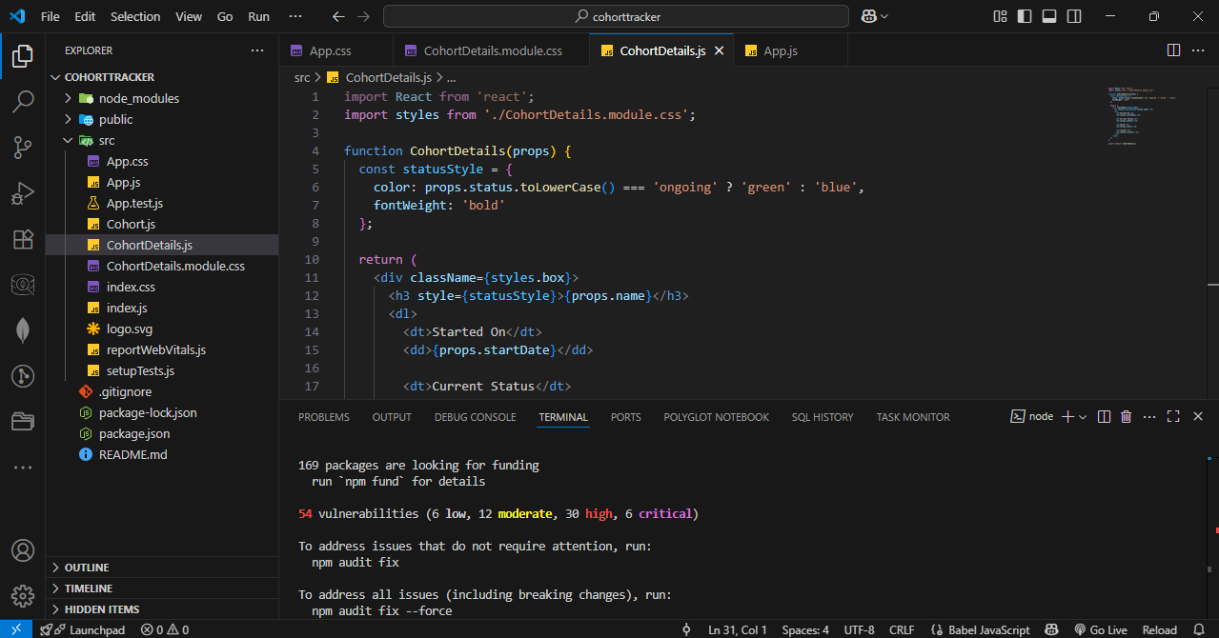

Step – 5 : Update App.js
Code :
import React from 'react';
import CohortDetails from './CohortDetails';

function App() {
return (
<div style={{ padding: '20px' }}>
<h1>Cohorts Details</h1>

<CohortDetails
name="INTADMDF10 - .NET FSD"
startDate="22-Feb-2022"
status="Scheduled"
coach="Aathma"
trainer="Jojo Jose"
/>

<CohortDetails
name="ADM21JF014 - Java FSD"
startDate="10-Sep-2021"
status="Ongoing"
coach="Apooorv"
trainer="Elisa Smith"
/>

<CohortDetails
name="CDBJF21025 - Java FSD"
startDate="24-Dec-2021"
status="Ongoing"
coach="Aathma"
trainer="John Doe"
/>
</div>
);
}

export default App;
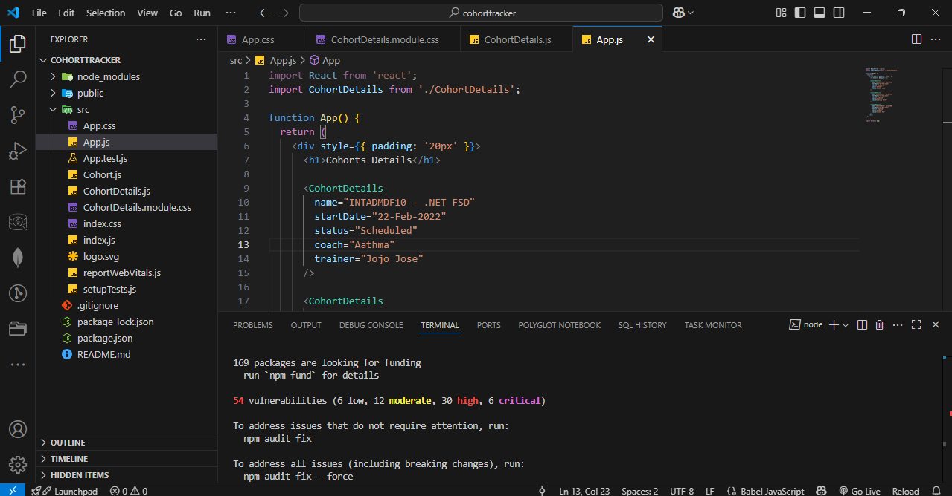

Step – 6 : Run the server.
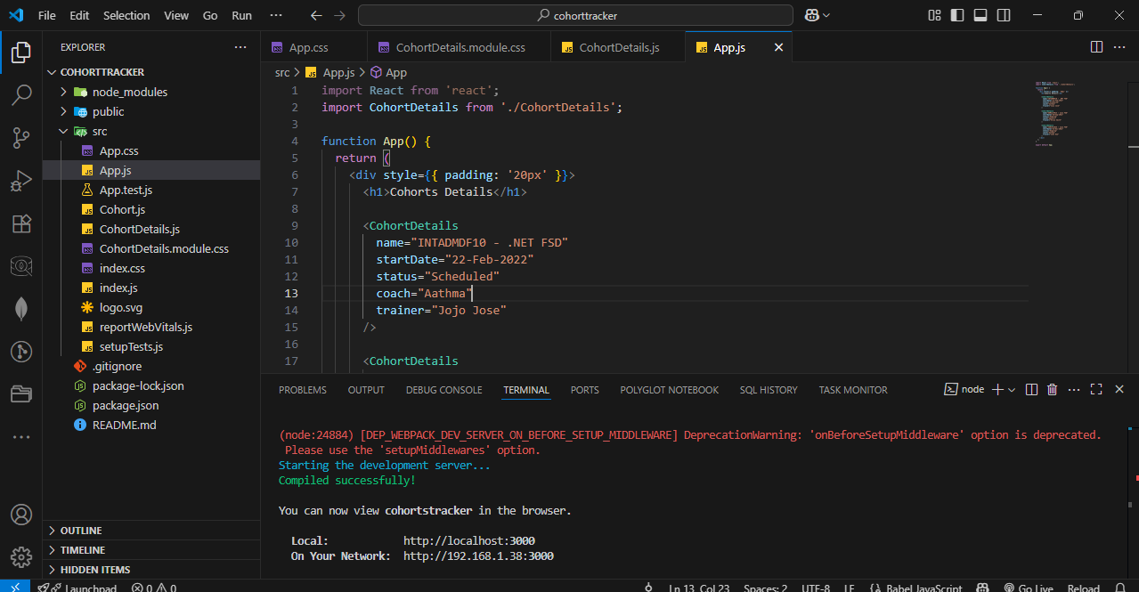

OUTPUT :
